Assignment 1

Q1. WAP to demonstrate ternary operator .define a variable marks  .ask its value from user and using ternary operator check if marks > 40 store "Pass" in result variable else store "Fail".

Ans.

**package** assign;

**import** java.util.*;

**public** **class** Ternop {

**public** **static** **void** main(String[] args) {

// **TODO** Auto-generated method stub

Scanner s= **new** Scanner(System.***in***);

System.***out***.println("enter number ");

**int** marks =s.nextInt();

String result = (marks > 40) ? "pass" : "fail";

System.***out***.println(result);

}

}

**Output:**

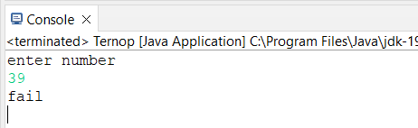

Q2. using ternary check if number entered by user is positive or negative .  
In case number is positive store "Positive number" else store negative number to Result variable.

Ans.

**package** assign;

**import** java.util.*;

**public** **class** Pnvalue {

**public** **static** **void** main(String[] args) {

// **TODO** Auto-generated method stub

Scanner s= **new** Scanner(System.***in***);

System.***out***.println("enter number ");

**int** num = s.nextInt();

String result = (num > 0) ? "your number is positive" : "your number is negative" ;

System.***out***.println(result);

}

}

**Output:**

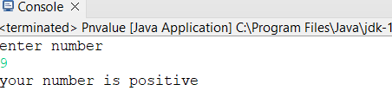

Q3 WAP to ask name ,age and salary of an employee and print on console.

Ans.

**package** assign;

**import** java.util.*;

**public** **class** Employee {

**public** **static** **void** main(String[] args){

// **TODO** Auto-generated method stub

Scanner s= **new** Scanner(System.***in***);

System.***out***.println("enter your name ->");

String name = s.nextLine();

System.***out***.println("enter your age -> ");

**int** age = s.nextInt();

System.***out***.println("enter your salary -> ");

**int** salary = s.nextInt();

System.***out***.println("your name is -> " +name);

System.***out***.println("your age is -> " +age);

System.***out***.println("your salary is -> " +salary);

}

}

**Output:**

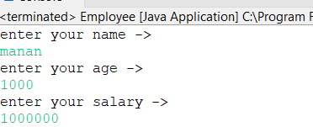

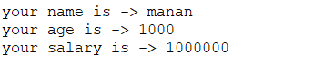

Q 4 wap  that ask two numbers from user and print greater number among two

Ans.

**package** assign;

**import** java.util.*;

**public** **class** Nocompr {

**public** **static** **void** main(String[] args) {

// **TODO** Auto-generated method stub

Scanner s= **new** Scanner(System.***in***);

System.***out***.println("enter first number -> ");

**int** i = s.nextInt();

System.***out***.println("enter second number-> ");

**int** j = s.nextInt();

**if**(i>j)

{

System.***out***.println("greater no is " +i);

}

**else**

{

System.***out***.println("greater no is " +j);

}

}

}

**Output:**

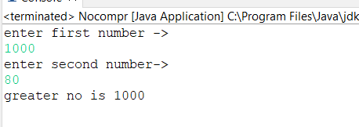

Q5. wap to ask product name and price of product from user and calculate discount i.e   
if price > 2000 then discount is 10 percent of price   
else   
discount is 7 % of price

Ans.

**package** assign;

**import** java.util.*;

**public** **class** Product {

**public** **static** **void** main(String[] args) {

// **TODO** Auto-generated method stub

Scanner s= **new** Scanner(System.***in***);

System.***out***.println("enter product name -> ");

String product = s.nextLine();

System.***out***.println("enter product price-> ");

**int** price = s.nextInt();

**int** discount;

**if**(price>2000)

{

discount=(price)*10/100;

System.***out***.println("discount is " +discount);

}

**else**

{

discount=(price)*7/100;

System.***out***.println("discount is " +discount );

}

}

}

**Output:**

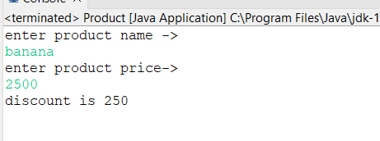

Q 6   Wap to swap two numbers

Ans.

**package** assign;

**import** java.util.*;

**public** **class** Swap {

**public** **static** **void** main(String[] args) {

// **TODO** Auto-generated method stub

Scanner s= **new** Scanner(System.***in***);

System.***out***.println("enter first no -> ");

**int** a = s.nextInt();

System.***out***.println("enter second no -> ");

**int** b = s.nextInt();

System.***out***.println("number before swap ->"+a+" "+b);

**int** temp;

temp=a;

a=b;

b=temp;

System.***out***.println("number after swap ->"+a+" " +b);

}

}

**Output:**

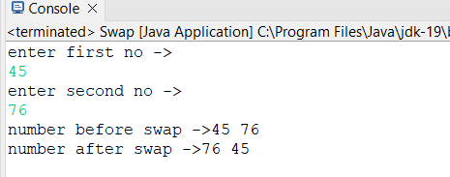

Q 7  How to swap two numbers without using a third variable?

**package** assign;

**import** java.util.*;

**public** **class** Newswap {

**public** **static** **void** main(String[] args) {

// **TODO** Auto-generated method stub

Scanner s= **new** Scanner(System.***in***);

System.***out***.println("enter first no -> ");

**int** a = s.nextInt();

System.***out***.println("enter second no -> ");

**int** b = s.nextInt();

System.***out***.println("number before swap ->"+a+" "+b);

a=a+b;

b=a-b;

a=a-b;

System.***out***.println("number after swap ->"+a+" "+b);

}

}

**Output:**

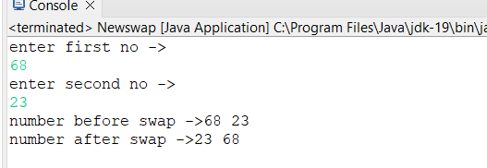

Q 8 wap to check is number is evenor odd.

Ans.

**package** assign;

**import** java.util.*;

**public** **class** Evod {

**public** **static** **void** main(String[] args) {

// **TODO** Auto-generated method stub

Scanner s= **new** Scanner(System.***in***);

System.***out***.println("enter your no -> ");

**int** a = s.nextInt();

**if**(a%2==0)

{

System.***out***.println("number is even ");

}

**else**

System.***out***.println("number is odd");

}

}

**Output:**

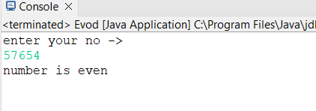

Q9.   A school has following rules for grading system:  
 a. Below 25 - F  
 b. 25 to 45 - E  
 c. 45 to 50 - D  
 d. 50 to 60 - C  
 e. 60 to 80 - B  
 f. Above 80 – A

 Ask user to enter marks and print the corresponding grade

Ans.

**package** assign;

**import** java.util.Scanner;

**public** **class** Gradecal {

**public** **static** **void** main(String[] args) {

// **TODO** Auto-generated method stub

Scanner s= **new** Scanner(System.***in***);

System.***out***.println("enter your percentage");

**int** per= s.nextInt();

**if**(per<25)

{

System.***out***.println("F");

}

**else** **if**(per>=25 && per<45 )

{

System.***out***.println("E");

}

**else** **if**(per>=45 && per<50 )

{

System.***out***.println("D");

}

**else** **if**(per>=50 && per <60)

{

System.***out***.println("C");

}

**else** **if**(per>=60 && per<80)

{

System.***out***.println("B");

}

**else** **if**(per>=80 && per<=100)

{

System.***out***.println("A");

}

**else**

{

System.***out***.println("per not valid");

}

}

}

**Output:**

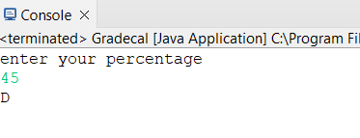

Q 10. wap to check greater number among three numbers

Ans.

**package** assign;

**import** java.util.Scanner;

**public** **class** Checkmax {

**public** **static** **void** main(String[] args) {

// **TODO** Auto-generated method stub

Scanner s= **new** Scanner(System.***in***);

System.***out***.println("enter first no a-> ");

**int** a = s.nextInt();

System.***out***.println("enter second no b-> ");

**int** b = s.nextInt();

System.***out***.println("enter third no c-> ");

**int** c = s.nextInt();

**if**(a>b)

{

**if**(a>c)

{

System.***out***.println("a is greatest");

}

}

**else** **if**(b>a)

{

**if**(b>c)

{

System.***out***.println("b is greatest");

}

}

**else** **if**(c>a)

{

**if**(c>b)

{

System.***out***.println("c is greatest");

}

}

}

}

**Output:**

